 | 7.1.5 Editors - 3D Viewport - Header - Select Menu
Table of content
Detailed Table of content 4
Select menu 12
Object Mode - Select menu 12
Legacy 12
Lasso Select 13
All 13
None 13
Inverse 13
Grouped 13
Linked 14
All by Type 14
Random 15
Mirror Selection 15
By Pattern 15
Active Camera 16
More/ Less 16
Mesh - Edit Mode 17
Legacy 17
Lasso Select 18
All 18
None 18
Invert 18
Linked 18
Linked Flat Faces 18
Linked Pick Select 18
Linked Pick Deselect 19
Similar 19
Random 19
Checker Deselect 20
Mirror selection 20
Side of Active 21
Shortest Path 21
Sharp Edges 22
Edge Loop 22
Edge Ring 22
Loop Inner-Region 23
Boundary Loop 23
Ungrouped Verts 23
All by Trait sub menu 23
Loose Geometry 24
Interior Faces 24
Faces by Sides 24
Poles by count 25
Select by Attribute 25
More / Less 25
Mesh Object - Vertex and Weight Paint Mode 26
Legacy 26
Lasso Select 26
All 27
None 27
Invert 27
Ungrouped Vertices 27
Select Linked 27
Linked 27
Linked Pick Select 27
Linked Pick Deselect 27
More/Less submenu 27
Mesh Object - Texture Paint Mode 28
Legacy 28
Lasso Select 28
All 28
None 29
Invert 29
Ungrouped Vertices 29
Select Linked 29
Linked 29
Linked Pick Select 29
Linked Pick Deselect 29
Select Loop 29
Add Loop to Selection 29
Remove Loop from Selection 30
More/Less submenu 30
Curve Object - Edit Mode 30
Legacy 30
Lasso Select 31
All 31
None 31
Invert 31
Linked 31
Linked Pick Select 31
Linked Pick Deselect 31
Similar 32
Random 32
Checker Deselect 32
De/Select First 33
De/Select Last 33
Next Active 33
Previous Active 33
Sub menu More / Less 33
Surface Object - Edit Mode 33
Legacy 34
Lasso Select 34
All 34
None 34
Inverse 34
Linked 34
Similar 35
Random 35
Checker Deselect 35
Control Point Row 36
Sub menu More / Less 36
Metaball Object - Edit Mode 36
Legacy 36
Lasso Select 37
All 37
None 37
Inverse 37
Similar 37
Random 37
Text Object - Edit Mode 38
All 38
Line End, Line Begin, etc. 38
Grease Pencil Object - Edit Mode, Vertex Paint Mode 38
Legacy 38
Lasso Select 39
All 39
None 39
Inverse 39
Linked 39
Select Similar 39
Alternated 40
Random 40
First 40
Last 40
Sub menu More / Less 41
Armature Object - Edit Mode 41
Legacy 41
Lasso Select 42
All 42
None 42
Inverse 42
Similar 42
Mirror Selection 43
By Pattern 43
Linked 44
Parent 44
Child 44
Extend Parent 44
Extend Child 44
Sub menu More / Less 44
Armature Object - Pose Mode 45
Legacy 45
Lasso Select 45
All 45
None 45
Inverse 46
Grouped 46
Linked 46
Bone Selection Set 46
Constraint Targets 46
By Pattern 46
Flip Active 47
Lattice Object - Edit Mode 48
Legacy 48
Lasso Select 48
All 48
None 48
Inverse 48
Mirror 49
Ungrouped Verts 49
Sub menu More / Less 49
Particles - Particle Mode 49
Legacy 50
Lasso Select 50
All 50
None 50
Inverse 50
More 50
Less 50
Linked 51
Random 51
Hair Curve – Edit Mode 51
All 51
None 51
Invert 51
Random 52
Endpoints 52
Linked 52
Select More/Less submenu 52
Hair Curve – Sculpt Mode 52
All 52
None 52
Invert 52
Random 52
Endpoints 52
Grow 53

Detailed Table of content

Detailed table of content
Detailed Table of content 4
Select menu 12
Object Mode - Select menu 12
Legacy 12
Box select 12
Circle select 13
Lasso Select 13
All 13
None 13
Inverse 13
Grouped 13
Last Operator Select Grouped 13
Extend 13
Type 13
Linked 13
Object Data 14
Material 14
Instanced Collection 14
Particle System 14
Library 14
Library (Object Data) 14
All by Type 14
Last Operator Select By Type 14
Extend 14
Type 14
Random 15
Last Operator Select Random 15
Percent 15
Random Seed 15
Action 15
Mirror Selection 15
Last Operator Select Mirror 15
Extend 15
By Pattern 15
Pattern 15
Case Sensitive 16
Extend 16
Last Operator Select Pattern 16
Active Camera 16
More/ Less 16
More 16
Less 16
Parent 16
Child 16
Parent extended 16
Child Extended 16
Mesh - Edit Mode 17
Legacy 17
Box select 17
Circle select 17
Lasso Select 18
All 18
None 18
Inverse 18
Linked 18
Last Operator Select Linked All 18
Delimit 18
Linked Flat Faces 18
Last Operator Select Linked Flat Faces 18
Linked Pick Select 18
Linked Pick Deselect 19
Last Operator Select Linked 19
Deselect 19
Delimit 19
Select Similar 19
Last Operator Select Similar 19
Type 19
Compare 19
Threshold 19
Random 19
Last Operator Select Random 20
Percent 20
Random Seed 20
Action 20
Checker Deselect 20
Last Operator Checker Deselect 20
Nth Element 20
Skip 20
Offset 20
Mirror selection 20
Last Operator Select Mirror 20
Axis 20
Extend 20
Side of Active 21
Last Operator Side of Active 21
Axis mode 21
Axis Sign 21
Axis 21
Threshold 21
Shortest Path 21
Last Operator Select shortest path 21
Face Stepping 21
Topology Distance 22
Fill Region 22
Nth Element 22
Skip 22
Offset 22
Sharp Edges 22
Last Operator Select Sharp Edges 22
Sharpness 22
Edge Loop 22
Last Operator Multi Select Loops 22
Ring 22
Edge Ring 22
Last Operator Multi Select Loops 23
Ring 23
Loop Inner-Region 23
Last Operator Select Loop Inner-Region 23
Select Bigger 23
Boundary Loop 23
Ungrouped Verts 23
Last Operator Select Ungrouped 23
Extend 23
Select all by Trait sub menu 23
Non Manifold 24
Last Operator Select Non-Manifold 24
Loose Geometry 24
Last Operator Select Loose Geometry 24
Extend 24
Interior Faces 24
Faces by Sides 24
Last Operator Select Faces by Side 24
Sharpness 24
Number of vertices 24
Type 24
Extend 25
Poles by count 25
Last Operator Select by Pole Count 25
Pole count 25
Type 25
Extend 25
Exclude Non Manifold 25
Select by Attribute 25
More / Less 25
More 25
Less 25
Next Active 26
Previous Active 26
Mesh Object - Vertex and Weight Paint Mode 26
Legacy 26
Box select 26
Circle select 26
Lasso Select 26
All 27
None 27
Invert 27
Ungrouped Vertices 27
Select Linked 27
Last Operator Select Linked All 27
Delimit 27
Linked 27
Linked Pick Select 27
Linked Pick Deselect 27
More/Less submenu 27
More 27
Less 28
Mesh Object - Texture Paint Mode 28
Legacy 28
Box select 28
Circle select 28
Lasso Select 28
All 28
None 28
Invert 29
Ungrouped Vertices 29
Select Linked 29
Last Operator Select Linked All 29
Delimit 29
Linked 29
Linked Pick Select 29
Linked Pick Deselect 29
Select Loop 29
Add Loop to Selection 29
Remove Loop from Selection 29
More/Less submenu 30
More 30
Less 30
Curve Object - Edit Mode 30
Legacy 30
Box select 30
Circle select 31
Lasso Select 31
All 31
None 31
Invert 31
Linked 31
Last Operator Select Linked All 31
Delimit 31
Linked Pick Select 31
Linked Pick Deselect 32
Last Operator Select Linked 32
Deselect 32
Delimit 32
Similar 32
Last Operator Select Similar 32
Type 32
Compare 32
Threshold 32
Random 32
Last Operator Select Random 32
Percent 32
Random Seed 32
Action 32
Checker Deselect 33
Last Operator Checker Deselect 33
Nth Element 33
Skip 33
Offset 33
De/Select First 33
De/Select Last 33
Next Active 33
Previous Active 33
More 33
Less 33
Surface Object - Edit Mode 33
Legacy 34
Box select 34
Circle select 34
Lasso Select 34
All 34
None 34
Inverse 34
Linked 34
Last Operator Select Linked All 35
Delimit 35
Similar 35
Last Operator Select Similar 35
Type 35
Compare 35
Threshold 35
Random 35
Last Operator Select Random 35
Percent 35
Random Seed 35
Action 35
Checker Deselect 35
Last Operator Checker Deselect 36
Nth Element 36
Skip 36
Offset 36
Control Point Row 36
More 36
Less 36
Metaball Object - Edit Mode 36
Legacy 36
Box select 36
Circle select 37
Lasso Select 37
All 37
None 37
Inverse 37
Similar 37
Last Operator Select Similar 37
Type 37
Compare 37
Threshold 37
Random 37
Last Operator Select Random 38
Percent 38
Random Seed 38
Action 38
Text Object - Edit Mode 38
All 38
Line End, Line Begin, etc. 38
Grease Pencil Object - Edit Mode, Vertex Paint Mode 38
Legacy 39
Box select 39
Circle select 39
Lasso Select 39
All 39
None 39
Inverse 39
Linked 40
Last Operator Select Linked All 40
Delimit 40
Select Similar 40
Last Operator Select Similar 40
Mode 40
Threshold 40
Alternated 40
Last Operator Alternated 40
Unselect Ends 40
Random 40
Last Operator Select Random 41
Ratio 41
Random Seed 41
Action 41
First 41
Last Operator Select First 41
Selected Strokes only 41
Extend 41
Last 41
Last Operator Select Last 41
Selected Strokes only 41
Extend 41
More 41
Less 41
Armature Object - Edit Mode 42
Legacy 42
Box select 42
Circle select 42
Lasso Select 42
All 42
None 42
Inverse 43
Similar 43
Last Operator Select Similar 43
Type 43
Compare 43
Threshold 43
Mirror Selection 43
Last Operator Select Mirror 43
Extend 43
By Pattern 43
Pattern 44
Case Sensitive 44
Extend 44
Last Operator Select Pattern 44
Parent 44
Child 44
Extend Parent 44
Extend Child 44
More 44
Less 45
Armature Object - Pose Mode 45
Legacy 45
Box select 45
Circle select 45
Lasso Select 45
All 45
None 45
Inverse 46
Grouped 46
Linked 46
Bone Selection Set 46
Constraint Targets 46
By Pattern 46
Pattern 47
Case Sensitive 47
Extend 47
Last Operator Select Pattern 47
Flip Active 47
Last Operator Flip Active/Selected Bone 47
Active Only 47
Extend 47
Parent 47
Child 47
Extend Parent 47
Extend Child 48
Lattice Object - Edit Mode 48
Legacy 48
Box select 48
Circle select 48
Lasso Select 48
All 48
None 48
Inverse 49
Mirror 49
Last Operator Select Mirror 49
Axis 49
Extend 49
Ungrouped Verts 49
Last Operator Select Ungrouped 49
Extend 49
More 49
Less 49
Particles - Particle Mode 49
Legacy 50
Box select 50
Circle select 50
Lasso Select 50
All 50
None 50
Inverse 50
More 50
Less 51
Linked 51
Random 51
Last Operator Select Random 51
Percent 51
Random Seed 51
Action 51
Type 51
Hair Curve – Edit Mode 51
All 51
None 51
Invert 52
Random 52
Endpoints 52
Linked 52
Select More/Less submenu 52
Hair Curve – Sculpt Mode 52
All 52
None 52
Invert 52
Random 52
Endpoints 53
Grow 53

Select menu

The Select menu provides you with all functionality around selecting. The content differs, dependent in which mode you are, and what object type you have selected. Some select functionality is very special for just one object type in one special mode. But not every mode has a select menu.

Object Mode - Select menu

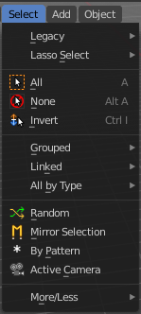
The select menu in Object mode is for all object types equal. It provides you with several selection methods.

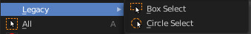
Legacy
The legacy sub menu contains tools that exists in the tool shelf already. It's the old way to do things. Different to the tools in the tool shelf, these tools are usually modal. And performs once. You have to call them again in case you want to repeat the tool.

Box select
Draw a rectangle to select everything inside of the rectangle.
It automatically adds to the current selection. Holding down shift subtracts from the selection.

Circle select
Brush select content. The radius of the brush can be adjusted by holding down left mouse button and using the scroll wheel or the + or - button at the numpad.
It automatically adds to the current selection. Holding down shift subtracts from the selection. To exit the circle select tool click with the right mouse button.

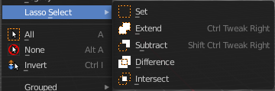
Lasso Select
A sub menu with the available lasso select modes.

All
Select everything.

None
Select nothing.

Inverse
Invert the current selection.

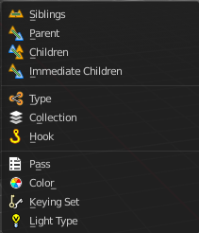
Grouped
Select different types of objects within the group. It requires to have a group selected.
The menu items are pretty self explaining. So we won't go into detail here.

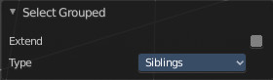
Last Operator Select Grouped

Extend
Extends existing selection instead of deselecting everything first.

Type
Type is a drop-down list choose the Linked type again.

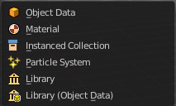
Linked
Linked is a menu select different types.
Select all objects that shares a common data-block with the active object. Select Linked uses the active object as a basis to select all others.

Object Data
Selects every object that is linked to the same Object Data.

Material
Selects every object that is linked to the same material data-block.

Instanced Collection
Selects every object that is linked to the instanced collection.

Particle System
Selects all objects that use the same Particle System.

Library
Selects all objects that are in the same Library.

Library (Object Data)
Selects all objects that are in the same Library and limited to object data.

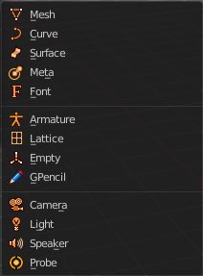
All by Type
Select objects of a specific type.
The menu items are pretty self explaining. So we won't cover every single menu item here.

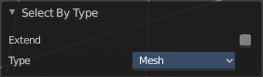
Last Operator Select By Type

Extend
With this option activated the selection does not clear before performing the selection operation, but extends. This means when you have a mesh object selected, and want to select all objects by type curve, then the mesh object is still selected. Without Extend just the curve objects are selected. The mesh object gets deselected.

Type
Type is a drop-down box choose the object type to select again.

Random
Selects random objects.

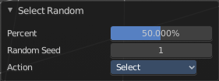
Last Operator Select Random

Percent
The Percentage of objects that should be selected randomly.

Random Seed
The Seed for the random number generator.

Action
Action is a drop-down box choose if you want to select or to deselect random.

Mirror Selection
Select the mirrored parts of an object. For example for L.Sword it selects R.Sword.

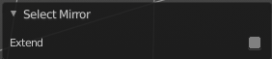
Last Operator Select Mirror

Extend
Extends existing selection instead of deselecting everything first.

By Pattern
Selects all objects whose name matches the entered string. For missing parts you need to add an asterix.
For example, you have four cubes in the scene. Cube, Cube.001, Cube.002 and mycube3. Then the term " Cube " will just select the first cube. While the term " Cube* " will select the first three. And " *cube* " will select all four.
Supported wild-cards:
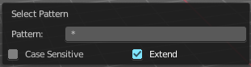
* matches everything
? matches any single character
[abc] matches characters in “abc”
[!abc] match any character not in “abc”
The tool operates immediately at entering the string.

Pattern
Type in your string.

Case Sensitive
When ticked then the string comparison happens by taking upper and lower letters into account.

Extend
Extends existing selection instead of deselecting everything first.

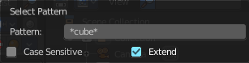
Last Operator Select Pattern
The Last Operator Select Pattern contains the same menu items than the pop-up. So see above. Also, it does not appear in the 3D view. But when you call it from the edit menu or with hotkey.

Active Camera
Selects the active camera.

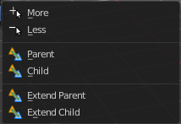
More/ Less

More
More requires to have a parent or child relationship. It expands the selection.

Less
Less requires to have a parent or child relationship. It reduces the selection.

Parent
Parent requires to have a parent or child relationship. It selects the parent object of the currently selected object(s).

Child
Child requires to have a parent or child relationship. It selects the child object(s) of the currently selected object(s).

Parent extended
Parent extended requires to have a parent or child relationship. It selects the parent object of the currently selected object(s). But keeps the active object in the selection, even when it's not currently selected.

Child Extended
Child Extended requires to have a parent or child relationship. It selects the child object(s) of the currently selected object(s). But keeps the active object in the selection, even when it's not currently selected.

Mesh - Edit Mode

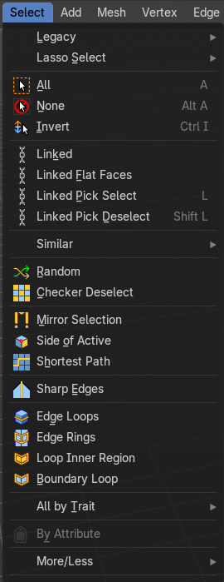
The select menu for a mesh object in Edit mode.
A few tools here acts different, dependent in which mesh select mode you are. For example, when you are in mesh select method vertices, then the Random operator picks random vertices.
So you might want to check the mesh select mode when something does not work in an expected way.

Legacy
The legacy sub menu contains tools that exists in the tool shelf already. It's the old way to do things. Different to the tools in the tool shelf, these tools are usually modal. And performs once. You have to call them again in case you want to repeat the tool.

Box select
Draw a rectangle to select everything inside of the rectangle.
It automatically adds to the current selection. Holding down shift subtracts from the selection.

Circle select
Brush select content. The radius of the brush can be adjusted by holding down left mouse button and using the scroll wheel or the + or - button at the numpad.
It automatically adds to the current selection. Holding down shift subtracts from the selection. To exit the circle select tool click with the right mouse button.

Lasso Select
A sub menu with the available lasso select modes.

All
Select everything.

None
Select nothing.

Invert
Invert the current selection.

Linked
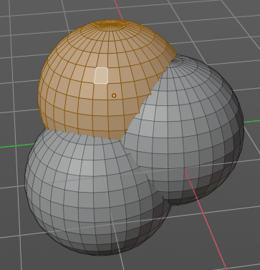
Select the geometry that is directly linked with the current geometry. You can for example have a mesh with several closed sub meshes. Those sub meshes. are not linked together, but are part of the object.

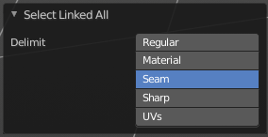
Last Operator Select Linked All

Delimit
Add a limit to the selection. For example, just select up to the next seam.

Linked Flat Faces
Select the geometry that is co planar to the current selection. It works also in other selection modes, but you need to have face geometry selected.

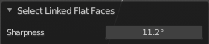
Last Operator Select Linked Flat Faces
Adjust the angle up to which a face counts as co planar.

Linked Pick Select
Same as with Linked. But works with what is under the mouse cursor.

Linked Pick Deselect
Same as with Linked. But works with what is under the mouse cursor. And deselects the selection.

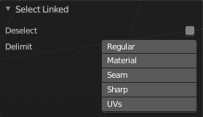
Last Operator Select Linked

Deselect
Select or deselect.

Delimit
Add a limit to the selection. For example, just select up to the next seam.

Similar
Select geometry based on how similar certain properties are to it. The methods changes, dependent in which mesh selection mode you are. There is a pitfall with having more than one mesh selection method selected. Then you just get the face regions type presented. Vertices, Edges, Faces, more than one ...
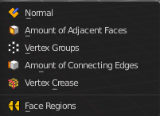
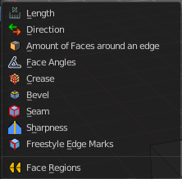
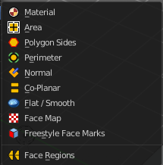
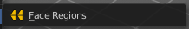

Last Operator Select Similar

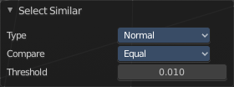
Type
Choose the select similar method again.

Compare
Compare with method less, greater or equal.

Threshold
Adjust the threshold value after which the element counts as similar.

Random
Selects a random group of vertices, edges, or faces, dependent of the mesh selection method.

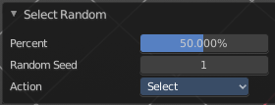
Last Operator Select Random

Percent
How much percent will be random selected.

Random Seed
The random seed value.

Action
Select or deselect.

Checker Deselect
Deselect alternating faces, edges or vertices to create a checker like pattern. The result is dependent of the mesh selection method.

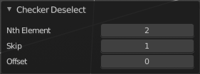
Last Operator Checker Deselect

Nth Element
Define how much elements gets unchecked. With 2 you have a checker board pattern. Every second element gets deselected.

Skip
Skip elements before the checker algorithm deselects again.

Offset
Offset the deselected elements.

Mirror selection
Requires to have a symmetrical mesh. Selects the mirrored mesh parts from a selection.

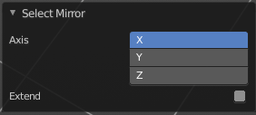
Last Operator Select Mirror

Axis
The world axis to mirror at.

Extend
Keep the current selection. Without extend the current selection gets deselected.

Side of Active
Selects all mesh data in direction of a single axis, starting from the current selection.

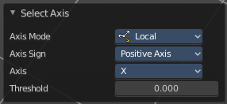
Last Operator Side of Active

Axis mode
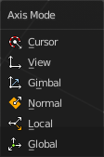
The axis orientation to work with.

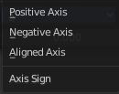
Axis Sign
In which direction to work form the current selection.

Axis
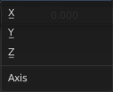
The axis to work with.

Threshold
Define a threshold to extend the selection.

Shortest Path
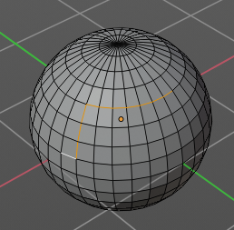
Select the shortest edge path between two selected mesh elements. This can be vertices, edges or faces. A start and an end point must be selected.

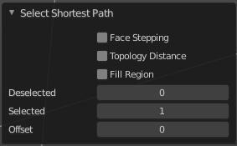
Last Operator Select shortest path

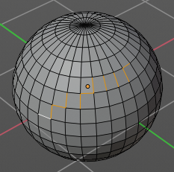
Face Stepping
Traverse connected faces.

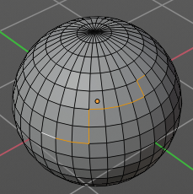
Topology Distance
Find the minimum number of steps instead of the shortest distance.

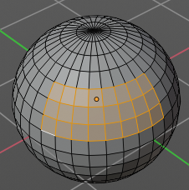
Fill Region
Select the region faces too.

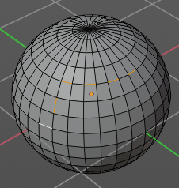
Nth Element
Don't select the whole path, but just every nth element of it.

Skip
This is connected to nth element. Number of elements to skip at once.

Offset
This is connected to nth element. Start with an offset.

Sharp Edges
Select all edges that are marked as sharp.

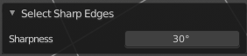
Last Operator Select Sharp Edges

Sharpness
The angle after which a sharp edge gets selected.

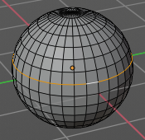
Edge Loop
Selects a loop of edges from a selected edge. The method stops at poles. That's vertices where three or more than four edges comes together. At a UV sphere the north and south pole ...

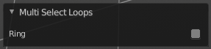
Last Operator Multi Select Loops

Ring
Select edge ring instead of edge loop.

Edge Ring
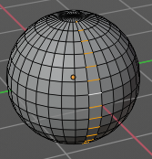
Selects edges parallel to a selected edge in the same ring of faces. The method stops at poles. That's vertices where three or more than four edges comes together. At a UV sphere the north and south pole ...

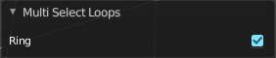
Last Operator Multi Select Loops

Ring
Select edge ring instead of edge loop.

Loop Inner-Region
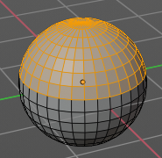
Select everything that is enclosed by an edge loop. When the loop is not closed, then it might select everything ...
By default the smaller enclosed part gets selected. The Inner-Region.

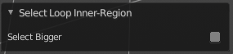
Last Operator Select Loop Inner-Region

Select Bigger
Select the bigger enclosed part instead of the smaller enclosed part.

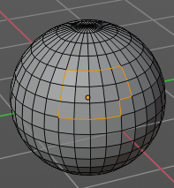
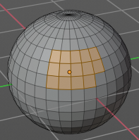
Boundary Loop
Select the edges that encloses a selection of faces.

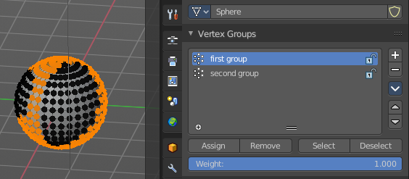
Ungrouped Verts
Selects ungrouped Vertices. Just active in vertex selection mode. And requires to have at least one vertex group assigned.

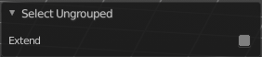
Last Operator Select Ungrouped

Extend
Extends the current selection.

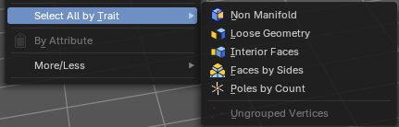
All by Trait sub menu

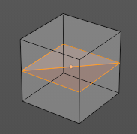
Non Manifold
Select non manifold geometry. Enclosed faces inside of a geometry for example.

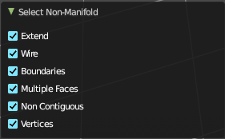
Last Operator Select Non-Manifold
What exact kind of non manifold geometry should be selected. The options names should be self explaining.

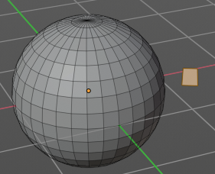
Loose Geometry
Selects loose geometry.

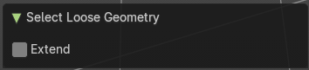
Last Operator Select Loose Geometry

Extend
Extend the current selection.

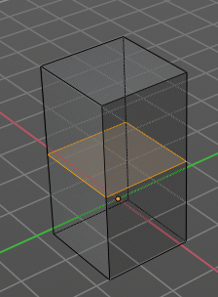
Interior Faces
Select faces where all edges have more than 2 faces. In the picture here we have inlaying faces by joining two cubes together, then merge the vertices by distance. So the two faces from the former two cubes are now interior faces. That's usually unwanted geometry that you want to select and to remove.

Faces by Sides
Selects faces that has the same number of edges, or better said vertices. Tris, quads, N-gons.

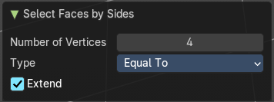
Last Operator Select Faces by Side

Sharpness
Extend the current selection.

Number of vertices
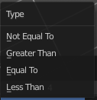
How many numbers of vertices the face should have. 4 is a quad.

Type
Selection type.

Extend
Extend the current selection.

Poles by count
Select poles. A pole is a vertice where more than four edges meet.

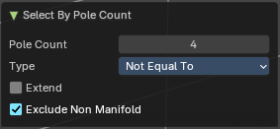
Last Operator Select by Pole Count

Pole count
What value to compare the vertice and its edges to. The number four here is the non pole value. Everything different will be treaten as a pole.

Type
How to compare to the pole count value.

Extend
Extend the current selection.

Exclude Non Manifold
Exclude non manifold geometry from the calculation.

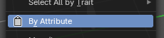
Select by Attribute
This operator selects elements based on the active boolean attribute. Useful for selection of boolean attributes set by Geometry Nodes.
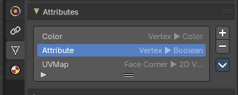
To use, make sure you have a boolean attribute assigned and selected in the Properties Editor - Mesh Data – Attributes tab.

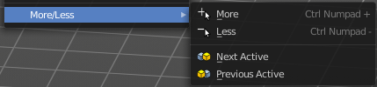
More / Less

More
Extends the current selection.

Less
Reduces the current selection.

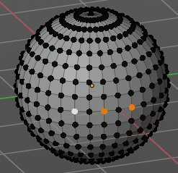
Next Active
Selects the next active element. For example, when you have two vertices selected, then the next vertice in the row with the same distance will be selected as the next active.

Previous Active
Like next active, but deselects in the other direction down to the first selected vertice with every step.

Mesh - Vertex and Weight Paint Mode
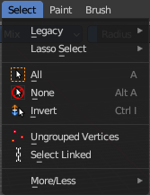
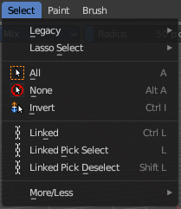
This select menu shows with the sub modes Paint Mask and Vertex Selection in vertex paint mode and weight paint mode.

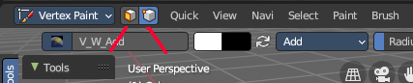

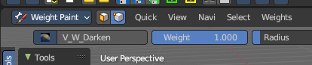

Legacy
The legacy sub menu contains tools that exists in the tool shelf already. It's the old way to do things. Different to the tools in the tool shelf, these tools are usually modal. And performs once. You have to call them again in case you want to repeat the tool.

Box select
Draw a rectangle to select everything inside of the rectangle.
It automatically adds to the current selection. Holding down shift subtracts from the selection.

Circle select
Brush select content. The radius of the brush can be adjusted by holding down left mouse button and using the scroll wheel or the + or - button at the numpad.
It automatically adds to the current selection. Holding down shift subtracts from the selection. To exit the circle select tool click with the right mouse button.

Lasso Select
A sub menu with the available lasso select modes.

All
Select everything.

None
Select nothing.

Invert
Invert the current selection.

Ungrouped Vertices
Vertex Selection Mode. Select vertices that does not belong to a group.

Select Linked
Vertex Selection Mode. Select the geometry that is directly linked with the current geometry. You can for example have a mesh with several closed sub meshes. Those sub meshes. are not linked together, but are part of the object.

Last Operator Select Linked All

Delimit
Add a limit to the selection. For example, just select up to the next seam.

Linked
Paint Mask mode. Select linked faces. Mouse only tool.

Linked Pick Select
Paint Mask mode. Select linked faces. Mouse only tool.

Linked Pick Deselect
Paint Mask mode. Deselect linked faces. Mouse only tool.

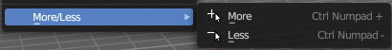
More/Less submenu

More
Icrease the selection.

Less
Decrease the selection.

Mesh - Texture Paint Mode
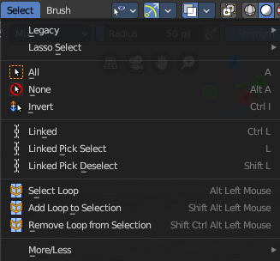
This select menu shows with the sub mode Paint Mask.
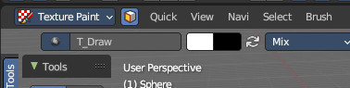

Legacy
The legacy sub menu contains tools that exists in the tool shelf already. It's the old way to do things. Different to the tools in the tool shelf, these tools are usually modal. And performs once. You have to call them again in case you want to repeat the tool.

Box select
Draw a rectangle to select everything inside of the rectangle.
It automatically adds to the current selection. Holding down shift subtracts from the selection.

Circle select
Brush select content. The radius of the brush can be adjusted by holding down left mouse button and using the scroll wheel or the + or - button at the numpad.
It automatically adds to the current selection. Holding down shift subtracts from the selection. To exit the circle select tool click with the right mouse button.

Lasso Select
A sub menu with the available lasso select modes.

All
Select everything.

None
Select nothing.

Invert
Invert the current selection.

Ungrouped Vertices
Vertex Selection Mode. Select vertices that does not belong to a group.

Select Linked
Vertex Selection Mode. Select the geometry that is directly linked with the current geometry. You can for example have a mesh with several closed sub meshes. Those sub meshes. are not linked together, but are part of the object.

Last Operator Select Linked All

Delimit
Add a limit to the selection. For example, just select up to the next seam.

Linked
Paint Mask mode. Select linked faces. Mouse only tool.

Linked Pick Select
Paint Mask mode. Select linked faces. Mouse only tool.

Linked Pick Deselect
Paint Mask mode. Deselect linked faces. Mouse only tool.

Select Loop
Selects a face loop. Mouse operator. The result is dependant of thhe face under the mouse. So please use the mouse.

Add Loop to Selection
Adds a face loop to an existing selection. Mouse operator. The result is dependant of thhe face under the mouse. So please use the mouse.

Remove Loop from Selection
Subtracts a face loop from an existing selection. Mouse operator. The result is dependant of thhe face under the mouse. So please use the mouse.

More/Less submenu

More
Icrease the selection.

Less
Decrease the selection.

Curve Object - Edit Mode

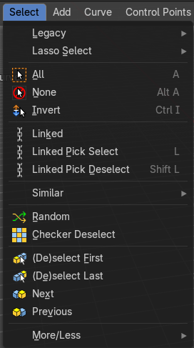

Legacy
The legacy sub menu contains tools that exists in the tool shelf already. It's the old way to do things. Different to the tools in the tool shelf, these tools are usually modal. And performs once. You have to call them again in case you want to repeat the tool.

Box select
Draw a rectangle to select everything inside of the rectangle.
It automatically adds to the current selection. Holding down shift subtracts from the selection.

Circle select
Brush select content. The radius of the brush can be adjusted by holding down left mouse button and using the scroll wheel or the + or - button at the numpad.
It automatically adds to the current selection. Holding down shift subtracts from the selection. To exit the circle select tool click with the right mouse button.

Lasso Select
A sub menu with the available lasso select modes.

All
Select everything.

None
Select nothing.

Invert
Invert the current selection.

Linked
Select the geometry that is directly linked with the current geometry. You can for example have a mesh with several closed sub meshes. Those sub meshes. are not linked together, but are part of the object.

Last Operator Select Linked All

Delimit
Add a limit to the selection. For example, just select up to the next seam.

Linked Pick Select
Same as with Linked. But works with what is under the mouse cursor.

Linked Pick Deselect
Same as with Linked. But works with what is under the mouse cursor. And deselects the selection.

Last Operator Select Linked

Deselect
Select or deselect.

Delimit
Add a limit to the selection. For example, just select up to the next seam.

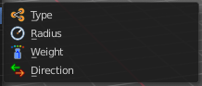
Similar
Select curve geometry based on how similar certain properties are to it.

Last Operator Select Similar

Type
Choose the select similar method again.

Compare
Compare with method less, greater or equal.

Threshold
Adjust the threshold value after which the element counts as similar.

Random
Selects a random group of curve points.

Last Operator Select Random

Percent
How much percent will be random selected.

Random Seed
The random seed value.

Action
Select or deselect.

Checker Deselect
Deselect alternating curve points.

Last Operator Checker Deselect

Nth Element
Define how much elements gets unchecked. With 2 you have a checker board pattern. Every second element gets deselected.

Skip
Skip elements before the checker algorithm deselects again.

Offset
Offset the deselected elements.

De/Select First
Select or deselect first curve point.

De/Select Last
Select or deselect last curve point.

Next Active
Selects the next active element. For example, when you have two vertices selected, then the next vertice in the row with the same distance will be selected as the next active.

Previous Active
Like next active, but deselects in the other direction down to the first selected vertice with every step.

Sub menu More / Less

More
Extends the current selection.

Less
Reduces the current selection.

Surface Object - Edit Mode

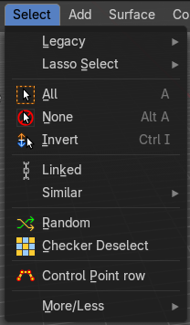

Legacy
The legacy sub menu contains tools that exists in the tool shelf already. It's the old way to do things. Different to the tools in the tool shelf, these tools are usually modal. And performs once. You have to call them again in case you want to repeat the tool.

Box select
Draw a rectangle to select everything inside of the rectangle.
It automatically adds to the current selection. Holding down shift subtracts from the selection.

Circle select
Brush select content. The radius of the brush can be adjusted by holding down left mouse button and using the scroll wheel or the + or - button at the numpad.
It automatically adds to the current selection. Holding down shift subtracts from the selection. To exit the circle select tool click with the right mouse button.

Lasso Select
A sub menu with the available lasso select modes.

All
Select everything.

None
Select nothing.

Inverse
Invert the current selection.

Linked
Select the geometry that is directly linked with the current geometry. You can for example have a mesh with several closed sub meshes. Those sub meshes are not linked together, but are part of the object.

Last Operator Select Linked All

Delimit
Add a limit to the selection. For example, just select up to the next seam.

Similar
Select curve geometry based on how similar certain properties are to it.

Last Operator Select Similar

Type
Choose the select similar method again.

Compare
Compare with method less, greater or equal.

Threshold
Adjust the threshold value after which the element counts as similar.

Random
Selects a random group of control points.

Last Operator Select Random

Percent
How much percent will be random selected.

Random Seed
The random seed value.

Action
Select or deselect.

Checker Deselect
Deselect alternating control points.

Last Operator Checker Deselect

Nth Element
Define how much elements gets unchecked. With 2 you have a checker board pattern. Every second element gets deselected.

Skip
Skip elements before the checker algorithm deselects again.

Offset
Offset the deselected elements.

Control Point Row
Selects a row of control points, including the active one.

Sub menu More / Less

More
Extends the current selection.

Less
Reduces the current selection.

Metaball Object - Edit Mode

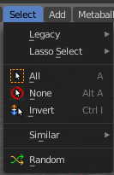

Legacy
The legacy sub menu contains tools that exists in the tool shelf already. It's the old way to do things. Different to the tools in the tool shelf, these tools are usually modal. And performs once. You have to call them again in case you want to repeat the tool.

Box select
Draw a rectangle to select everything inside of the rectangle.
It automatically adds to the current selection. Holding down shift subtracts from the selection.

Circle select
Brush select content. The radius of the brush can be adjusted by holding down left mouse button and using the scroll wheel or the + or - button at the numpad.
It automatically adds to the current selection. Holding down shift subtracts from the selection. To exit the circle select tool click with the right mouse button.

Lasso Select
A sub menu with the available lasso select modes.

All
Select everything.

None
Select nothing.

Inverse
Invert the current selection.

Similar
Select metaball geometry based on how similar certain properties are to it.

Last Operator Select Similar

Type
Choose the select similar method again.

Compare
Compare with method less, greater or equal.

Threshold
Adjust the threshold value after which the element counts as similar.

Random
Selects a random metaball element.

Last Operator Select Random

Percent
How much percent will be random selected.

Random Seed
The random seed value.

Action
Select or deselect.

Text Object - Edit Mode

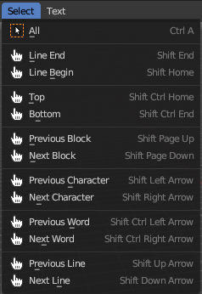
All
Select everything.

Line End, Line Begin, etc.
Select corresponding element.

Grease Pencil Object - Edit Mode, Vertex Paint Mode
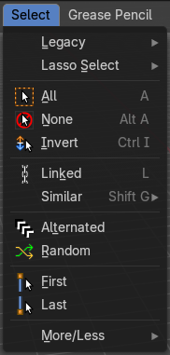
This is the select menu for the grease pencil object.

Legacy
The legacy sub menu contains tools that exists in the tool shelf already. It's the old way to do things. Different to the tools in the tool shelf, these tools are usually modal. And performs once. You have to call them again in case you want to repeat the tool.

Box select
Draw a rectangle to select everything inside of the rectangle.
It automatically adds to the current selection. Holding down shift subtracts from the selection.

Circle select
Brush select content. The radius of the brush can be adjusted by holding down left mouse button and using the scroll wheel or the + or - button at the numpad.
It automatically adds to the current selection. Holding down shift subtracts from the selection. To exit the circle select tool click with the right mouse button.

Lasso Select
A sub menu with the available lasso select modes.

All
Select everything.

None
Select nothing.

Inverse
Invert the current selection.

Linked
Select the geometry that is directly linked with the current geometry. You can for example have a mesh with several closed sub meshes. Those sub meshes. are not linked together, but are part of the object.

Last Operator Select Linked All

Delimit
Add a limit to the selection. For example, just select up to the next seam.

Select Similar
Select equal elements by the chosen method.

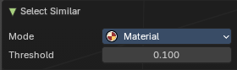
Last Operator Select Similar

Mode
The selection mode.

Threshold
How equal it really needs to be to count as equal.

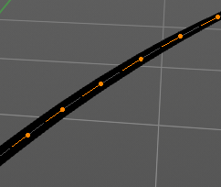
Alternated
Select every second element.

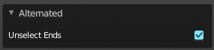
Last Operator Alternated

Unselect Ends
The end points are always unselected.

Random
Selects random elements.

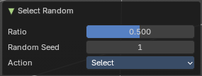
Last Operator Select Random

Ratio
The ratio of objects that should be selected randomly.

Random Seed
The Seed for the random number generator.

Action
Action is a drop-down box choose if you want to select or to deselect random.

First
Select the first element in the stroke.

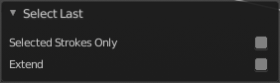
Last Operator Select First

Selected Strokes only
Only select the first point of strokes that has already some geometry selected.

Extend
Extend the current selection.

Last
Select the last element in the stroke.

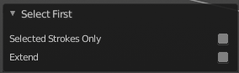
Last Operator Select Last

Selected Strokes only
Only select the last point of strokes that has already some geometry selected.

Extend
Extend the current selection.

Sub menu More / Less

More
Extends the current selection.

Less
Reduces the current selection.

Armature Object - Edit Mode

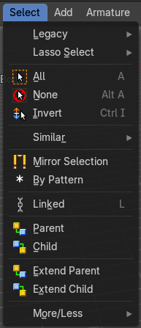

Legacy
The legacy sub menu contains tools that exists in the tool shelf already. It's the old way to do things. Different to the tools in the tool shelf, these tools are usually modal. And performs once. You have to call them again in case you want to repeat the tool.

Box select
Draw a rectangle to select everything inside of the rectangle.
It automatically adds to the current selection. Holding down shift subtracts from the selection.

Circle select
Brush select content. The radius of the brush can be adjusted by holding down left mouse button and using the scroll wheel or the + or - button at the numpad.
It automatically adds to the current selection. Holding down shift subtracts from the selection. To exit the circle select tool click with the right mouse button.

Lasso Select
A sub menu with the available lasso select modes.

All
Select everything.

None
Select nothing.

Inverse
Invert the current selection.

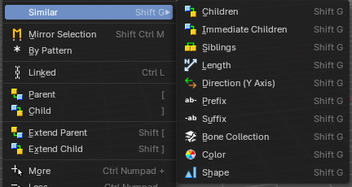
Similar
Select armature bones based on how similar certain properties are to it.
Most methods are self explaining. Immediate children selects just the direct children of the active object, while Children selects everything downwards the hierarchy.

Last Operator Select Similar

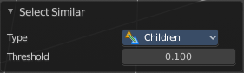
Type
Choose the select similar method again.

Compare
Compare with method less, greater or equal.

Threshold
Adjust the threshold value after which the element counts as similar.

Mirror Selection
Select the mirrored parts of an object. For example for L.bone it selects R.bone.

Last Operator Select Mirror

Extend
Extends existing selection instead of deselecting everything first.

By Pattern
Selects all objects whose name matches the entered string. For missing parts you need to add an asterix.
For example, you have four cubes in the scene. Cube, Cube.001, Cube.002 and mycube3. Then the term " Cube " will just select the first cube. While the term " Cube* " will select the first three. And " *cube* " will select all four.
Supported wild-cards:
* matches everything
? matches any single character
[abc] matches characters in “abc”
[!abc] match any character not in “abc”
The tool operates immediately at entering the string.

Pattern
Type in your string.

Case Sensitive
When ticked then the string comparison happens by taking upper and lower letters into account.

Extend
Extends existing selection instead of deselecting everything first.

Last Operator Select Pattern
The Last Operator Select Pattern contains the same menu items than the pop-up. So see above. Also, it does not appear in the 3D view. But when you call it from the edit menu or with hotkey.

Linked
Select all bones linked by parent.

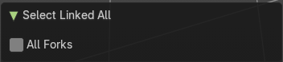
Last Operator Select Linked All

All Forks
Follow forks in the parents chain. Means select upwards too.

Parent
Parent requires to have a parent or child relationship. It selects the parent object of the currently selected object(s).

Child
Child requires to have a parent or child relationship. It selects the child object(s) of the currently selected object(s).

Extend Parent
Extend Parent requires to have a parent or child relationship. It selects the parent object of the currently selected object(s). But keeps the active object in the selection, even when it's not currently selected.

Extend Child
Extend Child requires to have a parent or child relationship. It selects the child object(s) of the currently selected object(s). But keeps the active object in the selection, even when it's not currently selected.

Sub menu More / Less

More
More requires to have a parent or child relationship. It expands the selection.

Less
Less requires to have a parent or child relationship. It reduces the selection.

Armature Object - Pose Mode
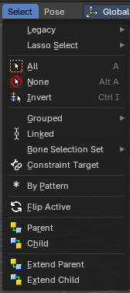

Legacy
The legacy sub menu contains tools that exists in the tool shelf already. It's the old way to do things. Different to the tools in the tool shelf, these tools are usually modal. And performs once. You have to call them again in case you want to repeat the tool.

Box select
Draw a rectangle to select everything inside of the rectangle.
It automatically adds to the current selection. Holding down shift subtracts from the selection.

Circle select
Brush select content. The radius of the brush can be adjusted by holding down left mouse button and using the scroll wheel or the + or - button at the numpad.
It automatically adds to the current selection. Holding down shift subtracts from the selection. To exit the circle select tool click with the right mouse button.

Lasso Select
A sub menu with the available lasso select modes.

All
Select everything.

None
Select nothing.

Inverse
Invert the current selection.

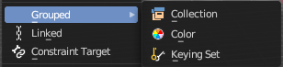
Grouped
Select grouped bones by type. Items should be self explaining.

Linked
Select all bones that are either parent or child of the selected bone.

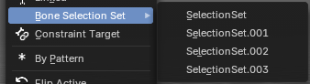
Bone Selection Set
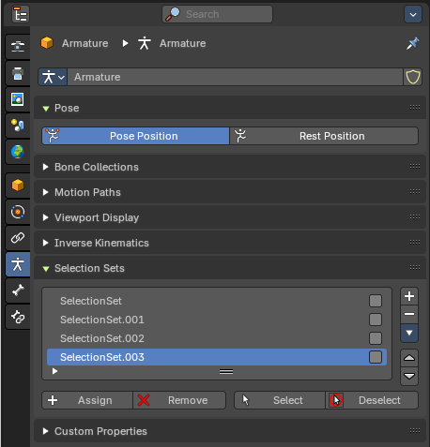
Select a bone selection. Bone selections can be created and managed in the Properties editor in the object Data Properties in the Selection Sets Panel.

Constraint Targets
Select the bones used as targets for the currently selected bone.

By Pattern
Selects all objects whose name matches the entered string. For missing parts you need to add an asterix.
For example, you have four cubes in the scene. Cube, Cube.001, Cube.002 and mycube3. Then the term " Cube " will just select the first cube. While the term " Cube* " will select the first three. And " *cube* " will select all four.
Supported wild-cards:
* matches everything
? matches any single character
[abc] matches characters in “abc”
[!abc] match any character not in “abc”
The tool operates immediately at entering the string.

Pattern
Type in your string.

Case Sensitive
When ticked then the string comparison happens by taking upper and lower letters into account.

Extend
Extends existing selection instead of deselecting everything first.

Last Operator Select Pattern
The Last Operator Select Pattern contains the same menu items than the pop-up. So see above. Also, it does not appear in the 3D view. But when you call it from the edit menu or with hotkey.

Flip Active
Mirrors the bone selection. Works with an armature with mirrored parts.

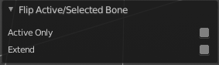
Last Operator Flip Active/Selected Bone

Active Only
Only select the mirror part of the active bone.

Extend
Extend the current selection.

Parent
Parent requires to have a parent or child relationship. It selects the parent object of the currently selected object(s).

Child
Child requires to have a parent or child relationship. It selects the child object(s) of the currently selected object(s).

Extend Parent
Extend Parent requires to have a parent or child relationship. It selects the parent object of the currently selected object(s). But keeps the active object in the selection, even when it's not currently selected.

Extend Child
Extend Child requires to have a parent or child relationship. It selects the child object(s) of the currently selected object(s). But keeps the active object in the selection, even when it's not currently selected.

Lattice Object - Edit Mode
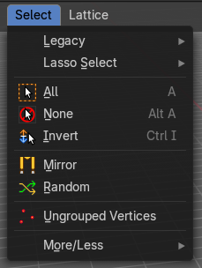

Legacy
The legacy sub menu contains tools that exists in the tool shelf already. It's the old way to do things. Different to the tools in the tool shelf, these tools are usually modal. And performs once. You have to call them again in case you want to repeat the tool.

Box select
Draw a rectangle to select everything inside of the rectangle.
It automatically adds to the current selection. Holding down shift subtracts from the selection.

Circle select
Brush select content. The radius of the brush can be adjusted by holding down left mouse button and using the scroll wheel or the + or - button at the numpad.
It automatically adds to the current selection. Holding down shift subtracts from the selection. To exit the circle select tool click with the right mouse button.

Lasso Select
A sub menu with the available lasso select modes.

All
Select everything.

None
Select nothing.

Inverse
Invert the current selection.

Mirror
Select the mirrored parts to the current selection.

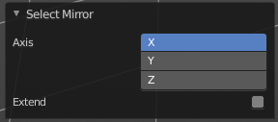
Last Operator Select Mirror

Axis
Choose the world axis to mirror at.

Extend
Extends existing selection instead of deselecting everything first.

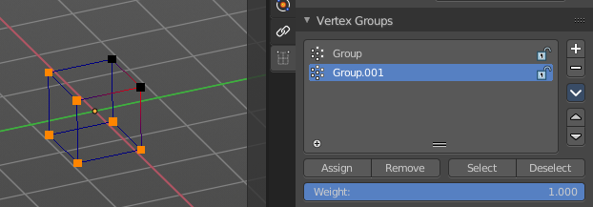
Ungrouped Verts
Selects ungrouped Vertices. Requires to have at least one vertex group assigned.

Last Operator Select Ungrouped

Extend
Extends the current selection instead of deselecting everything first.

Sub menu More / Less

More
Extends the current selection.

Less
Reduces the current selection.

Particles - Particle Mode
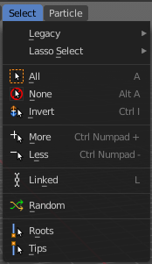

Legacy
The legacy sub menu contains tools that exists in the tool shelf already. It's the old way to do things. Different to the tools in the tool shelf, these tools are usually modal. And performs once. You have to call them again in case you want to repeat the tool.

Box select
Draw a rectangle to select everything inside of the rectangle.
It automatically adds to the current selection. Holding down shift subtracts from the selection.

Circle select
Brush select content. The radius of the brush can be adjusted by holding down left mouse button and using the scroll wheel or the + or - button at the numpad.
It automatically adds to the current selection. Holding down shift subtracts from the selection. To exit the circle select tool click with the right mouse button.

Lasso Select
A sub menu with the available lasso select modes.

All
Select everything.

None
Select nothing.

Inverse
Invert the current selection.

More
Extends the current selection.

Less
Reduces the current selection.

Linked
Selects the linked particles.

Random
Selects random particles.

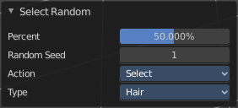
Last Operator Select Random

Percent
The Percentage of objects that should be selected randomly.

Random Seed
The Seed for the random number generator.

Action
Action is a drop-down box choose if you want to select or to deselect random.

Type
Select the whole hair, or hair points.

Hair Curve – Edit Mode
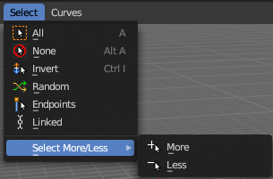
The (Empty) Hair Curve object in the Edit mode has a select menu. Here you can select existing curves in different ways to mask selections for tool shelf operators. Selected curves are editable, deselected curves are locked from editing and are visually opaque with dark gray in the 3D View editor.

All
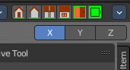
Selects all the control points of the hair strands.
If you want a want a symmetrical haircut, tick X Mirror in the Symmetry panel or in the Header to the top right.

None
Deselects all the control points of the hair curves.

Invert
Deselects all the control points of the hair curves.

Random
Randomizes existing selection or creates a new random selection of control points of the hair curves.

Endpoints
Selects the end points of the control points of the hair curves.

Linked
Select linked control points.

Select More/Less submenu
Grow or shrink the selection.

Hair Curve – Sculpt Mode
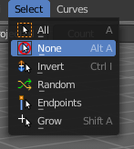
The (Empty) Hair Curve object in the Sculpt mode has a select menu. Here you can select existing curves in different ways to mask selections for tool shelf operators. Selected curves are editable, deselected curves are locked from editing and are visually opaque with dark gray in the 3D View editor.

All
Selects all the control points of the hair strands.
If you want a want a symmetrical haircut, tick X Mirror in the Symmetry panel or in the Header to the top right.

None
Deselects all the control points of the hair curves.

Invert
Deselects all the control points of the hair curves.

Random
Randomizes existing selection or creates a new random selection of control points of the hair curves.

Endpoints
Selects the end points of the control points of the hair curves.

Grow
Select curves which are close to curves that are selected already.

